MY SQL ASSIGNMENT 3

(Sanchay Shukla)

**Creating database and table.**

CREATE DATABASE IF NOT EXISTS CompanyDB;

USE CompanyDB;

CREATE TABLE IF NOT EXISTS Employees (

emp_id INT PRIMARY KEY AUTO_INCREMENT,

first_name VARCHAR(50) NOT NULL,

last_name VARCHAR(50) NOT NULL,

department VARCHAR(50) NOT NULL,

salary DECIMAL(15, 2) NOT NULL,

hire_date DATE NOT NULL

);

INSERT INTO Employees (first_name, last_name, department, salary, hire_date) VALUES

('John', 'Doe', 'IT', 60000.00, '2019-01-10'),

('Jane', 'Smith', 'HR', 55000.00, '2018-03-05'),

('Emily', 'Jones', 'IT', 62000.00, '2020-07-23'),

('Michael', 'Brown', 'Finance', 70000.00, '2016-05-14'),

('Sarah', 'Davis', 'Finance', 69000.00, '2017-11-18'),

('David', 'Johnson', 'HR', 48000.00, '2021-09-10');

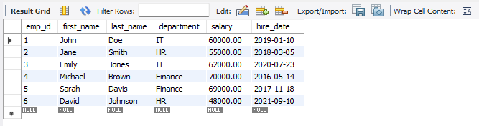

**Now solving the assignment.**

**-- 1. Find the average salary of employees in each department.**

SELECT department, AVG(salary) AS AvgSalary

FROM Employees

GROUP BY department;

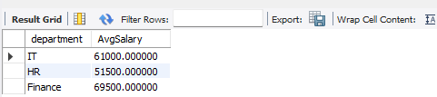

**-- 2. Find the total number of employees hired after 2019.**

SELECT COUNT(*) AS TotalEmployeesHiredAfter2019

FROM Employees

WHERE hire_date > '2019-12-31';



**-- 3. List the departments and the total salary of all employees in each department, ordered by the total salary.**

SELECT department, SUM(salary) AS TotalSalary

FROM Employees

GROUP BY department

ORDER BY TotalSalary DESC;

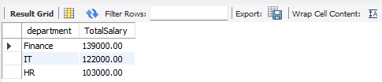

**-- 4. Find the highest salary in the Finance department.**

SELECT MAX(salary) AS HighestSalaryInFinance

FROM Employees

WHERE department = 'Finance';



**-- 5. Get the top 3 highest-paid employees.**

SELECT first_name, last_name, salary

FROM Employees

ORDER BY salary DESC

LIMIT 3;

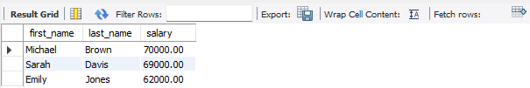

**-- 6. Find the department with the minimum average salary.**

SELECT department, AVG(salary) AS AvgSalary

FROM Employees

GROUP BY department

ORDER BY AvgSalary ASC

LIMIT 1;

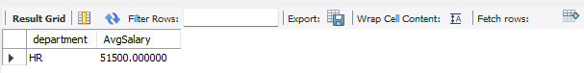

**-- 7. Display the total number of employees in each department, ordered by the number of employees.**

SELECT department, COUNT(*) AS NumberOfEmployees

FROM Employees

GROUP BY department

ORDER BY NumberOfEmployees DESC;

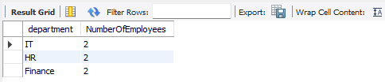

**-- 8. Find the average salary of employees who were hired before 2020.**

SELECT AVG(salary) AS AvgSalaryBefore2020

FROM Employees

WHERE hire_date < '2020-01-01';



**-- 9. List the names of employees in the IT department ordered by hire date, with the most recently hired employees first.**

SELECT first_name, last_name

FROM Employees

WHERE department = 'IT'

ORDER BY hire_date DESC;

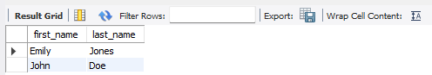

**-- 10. Find the sum of salaries for all employees hired after January 1, 2019, ordered by salary.**

SELECT first_name, last_name, salary

FROM Employees

WHERE hire_date > '2019-01-01'

ORDER BY salary;



**-- 11. Get the employee with the lowest salary in the HR department.**

SELECT first_name, last_name, salary

FROM Employees

WHERE department = 'HR'

ORDER BY salary ASC

LIMIT 1;



**-- 12. Find the total salary paid to employees in each department, but limit the result to the top 2 highest-paying departments.**

SELECT department, SUM(salary) AS TotalSalary

FROM Employees

GROUP BY department

ORDER BY TotalSalary DESC

LIMIT 2;

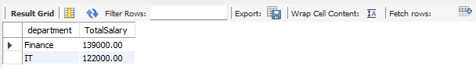

**-- 13. List all employees hired after 2018, ordered by salary, and show only the first 4 employees.**

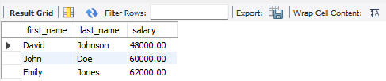

SELECT first_name, last_name, salary

FROM Employees

WHERE hire_date > '2018-12-31'

ORDER BY salary

LIMIT 4;

**-- 14. Find the highest salary in the IT department, but limit the results to the top 1 result.**

SELECT MAX(salary) AS HighestSalaryInIT

FROM Employees

WHERE department = 'IT'

LIMIT 1;

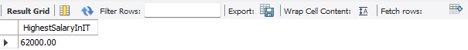

**-- 15. Get the average salary of employees in each department and list only departments with an average salary greater than $60,000.**

SELECT department, AVG(salary) AS AvgSalary

FROM Employees

GROUP BY department

HAVING AVG(salary) > 60000;

